Task 6 and Task 8 - Updated Sections with Workflow Diagrams

Task 6: Manage the delivery information of the order
Task: Manage the delivery information of the order
Purpose:
Ensure accurate delivery information is collected and maintained for each order to guarantee successful and timely shipment.
Trigger/Precondition:
Customer has placed an order and must provide delivery information. They may later wish to modify it if needed.
Frequency:
Occurs every time a customer places an order or updates delivery details.
Critical:
Inaccurate or delayed delivery information may cause shipment errors and customer dissatisfaction.
Work Area:
Customer Profile and Admin Dashboard
Subtasks and Variants:
Subtask | Example Solution | Variant
Enter shipping details | Customer inputs delivery address during checkout. | Invalid address — System prompts re-entry before proceeding.
Confirm delivery details | System shows summary for confirmation before finalizing. | Customer omits required field — System flags the field and prevents continuation.
Track order delivery status | System updates order status and notifies the customer. | Tracking info unavailable — System shows “Pending” status.
Modify delivery information | Customer modifies delivery address before a deadline; system verifies and updates. | Deadline passed — System disables editing and advises to contact support.
Confirm delivery completed | System updates delivery as completed after confirmation from courier or customer. | Delivery failed — System allows admin to reschedule or escalate.
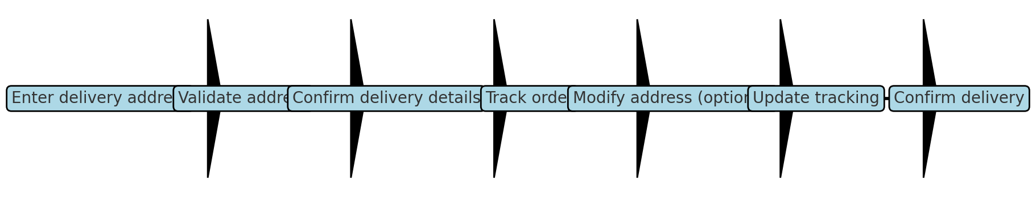

Task 8: Show basic statistics about the goods sold
Task: Show basic statistics about the goods sold
Purpose:
Allow the owner to generate a simple report of goods sold over different time periods for business insights.
Trigger/Precondition:
Owner initiates the request for viewing or exporting sales statistics.
Frequency:
Daily, weekly, or on demand.
Critical:
Incorrect or missing data may lead to poor decision-making.
Work Area:
Admin Dashboard – Reports Section
Subtasks and Variants:
Subtask | Example Solution | Variant
Select time period | Owner selects time range for report (day, week, month, custom). | Invalid time input — System prompts correct formatting.
Generate report | System compiles sales data and visualizes it as graphs/tables. | No data for range — System shows “No sales data available.”
Export or share report | Owner exports report to PDF/CSV or shares via email. | Export error — System advises retry or switch format.
Filter data (optional) | Owner applies filters (e.g., product category, region). | Filter returns empty set — System resets filter and informs owner.
